**YouTube Marketing:** YouTube is a serious marketing platform that provides your brand with the opportunity to promote content in a truly visual and engaging way. It’s essential to practice inbound marketing techniques when marketing your YouTube channel and videos. Create content that shares an interesting story and provides your viewers with valuable information.

**How does YouTube use marketing?**

It is marketing on YouTube. YouTube can be used to drive traffic towards your desired target Web site by creating a video with content created specifically to appeal to your target market. Since, this social media tool is free, everyone can use it for their own personal or professional purposes – as long as what you produce is legal.

**10-step YouTube marketing strategy**

Step 1. Create a YouTube channel for business

Step 2. Learn about your audience

Step 3. Research your competition

Step 4. Learn from your favourite channels

Step 5. Optimize your videos to get views

Step 6. Upload and schedule your videos

Step 7. Optimize your channel to attract followers

Step 8. Try YouTube advertising

Step 9. Try working with an influencer

Step 10. Analyze and adapt

Link: [Click hare](https://blog.hootsuite.com/youtube-marketing/)

**How to Create a YouTube Channel**

So, you’ve decided to create a [**YouTube channel**](https://www.hubspot.com/integrations/youtube?_ga=2.211846356.1387180219.1620756293-1027591804.1620756293). Great! Now, you’ll need a YouTube Marketing strategy to help you identify goals, decide on video topics, and properly promote your brand on your new channel.

Before we dive in, it’s important to note that maintaining a YouTube channel takes a lot of time and planning. Are you ready for it?

Unlike other social networking platforms, YouTube exclusively hosts video content. You’ll need to set aside time to plan, film, edit, market, and analyze your content on a consistent basis. You’ll also need to define your brand’s goals and plan for how video can specifically help you achieve these. If you can devote an appropriate amount of time and energy to the platform, you’ll be able to create engaging, shareable content for your growing audience.

**Creating a Google Account:**

Before you start filming video content, you’ll need to set up your YouTube channel. Because YouTube is owned by Google, when you sign up for a Gmail account, you automatically gain access to a YouTube account, a Google+ account, and much more.

Depending on your business, you may not want to tie your email to your business’s YouTube channel — especially if you need to share access to the account with team members or an agency partner. We suggest that you create a common email account that can be used by multiple people.

**Step 1:** [**Visit Google**](http://google.com/) and click **Sign in**in the upper right-hand corner.

**Step 2:**Click on **Create account** at the bottom of the page.

**Step 3:** You’ll see an option pop up to create an account for yourself or to manage your business. Since your YouTube account will be for your business, choose **To manage my business**.

**Step 4:** To officially create your Google account, enter your name and desired email and password before clicking **Next**. Then, enter a recovery email and your birthday, gender, and phone number.

Note: Google requires all users to be at least 13 years old.

**Step 5:** Lastly, agree to Google’s Privacy Policy and Terms of Service and verify your account with a code sent via text or phone call. Congrats! You’re now the proud owner of a Google account.

### Creating a YouTube Account:

Now that you have a Google account, you’re almost ready to publish some awesome video content.

But, we’re not done quite yet — you now need to set up a YouTube Brand Account. A Brand Account allows users to manage editing permissions and create a more holistic online presence.

**Step 1:** [**Visit YouTube**](http://youtube.com/). In the upper right-hand corner, note that you’re probably already logged into your new Google account. (If you’re not, click **Sign in** and enter your new Google account username and password.)

**Step 2:** Once you’ve signed in, click your **account module** and click **Your channel** in the drop-down menu.

**Step 3:** You’ll see two options for creating your channel. Choose **Use a custom name**.

**Step 4:** Now, you should be prompted to create your channel name.

Note: You can always [**update or change your channel name from your account settings**](https://support.google.com/youtube/answer/2657964?co=GENIE.Platform%3DAndroid&hl=en), so don’t worry if you aren’t 100% sure about your selected label.

Source: <https://www.hubspot.com/youtube-marketing>

# 18 YouTube Marketing Strategy Tips for Beginners:

Have you been dreaming of your own YouTube channel for a while, but have no idea where to start? Then, you’ve come to the right place! In this article, we’ll give you a complete guide to YouTube marketing strategy, which you can start implementing now to grow your channel from zero.

Together, we’ll discover how to attract visitors to your channel and get them to subscribe, how to create the right content for your audience, how to brand your channel, and so much more about YouTube marketing. Let’s go!

* [Understand Your Target Audience](https://www.renderforest.com/blog/youtube-marketing-strategy)
* [Know Your Competition](https://www.renderforest.com/blog/youtube-marketing-strategy)
* [Define Your Value Proposition](https://www.renderforest.com/blog/youtube-marketing-strategy)
* [Brand Your Channel](https://www.renderforest.com/blog/youtube-marketing-strategy)
* [Create a Channel Trailer](https://www.renderforest.com/blog/youtube-marketing-strategy)
* [Invest in High-Quality Equipment](https://www.renderforest.com/blog/youtube-marketing-strategy)
* [Track Your Analytics](https://www.renderforest.com/blog/youtube-marketing-strategy)
* [Collaborate with Other Channels](https://www.renderforest.com/blog/youtube-marketing-strategy)
* [Find the Right Keywords](https://www.renderforest.com/blog/youtube-marketing-strategy)
* [Consider the Search Intent](https://www.renderforest.com/blog/youtube-marketing-strategy)
* [Use Your Keywords](https://www.renderforest.com/blog/youtube-marketing-strategy)
* [Make Irresistible Intros](https://www.renderforest.com/blog/youtube-marketing-strategy)
* [Be Concise](https://www.renderforest.com/blog/youtube-marketing-strategy)
* [Optimize the Titles](https://www.renderforest.com/blog/youtube-marketing-strategy)
* [Make Custom Thumbnails](https://www.renderforest.com/blog/youtube-marketing-strategy)
* [Add Closed Captions](https://www.renderforest.com/blog/youtube-marketing-strategy)
* [Include Calls-to-Action](https://www.renderforest.com/blog/youtube-marketing-strategy)
* [Cross-Promote Your Videos](https://www.renderforest.com/blog/youtube-marketing-strategy)

## ****Part 1: Tips for the Channel as a Whole****

##### 

## 1. Understand Your Target Audience

By now, you probably have an idea what your channel is going to be about. But, have you thought about your audience, who they are, and why they’d want to watch your videos?

In order for your YouTube channel to be successful, each video should be created having your [target audience](https://www.renderforest.com/blog/define-target-audience) in mind. It should be perfectly tailored to their interests, needs, and watching preferences.

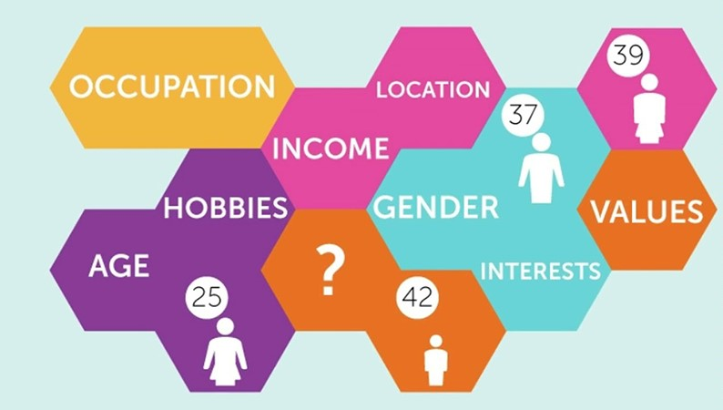

##### **Image: Local Advertising Journal**

##### 

Let’s say you have a cooking channel where you upload quick recipe videos on YouTube for people with busy lifestyles. Considering the fact that your audience is very frugal with their time, you’d make your videos short and concise like the recipes. Notice how in both videos each recipe is about half a minute long.

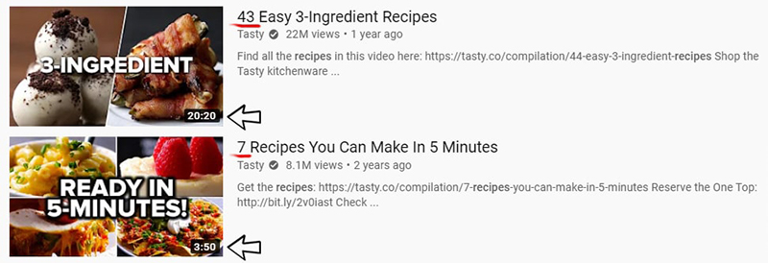

This is but one example of tailoring your videos to your audience.